Email ID: nazeemajid987@gmail.com






[TOURISM REVENUE OPTIMIZATION & CANCELLATION REDUCTION DASHBOARD]

Project Domain
Excel, Power BI and Copilot

A Project Report
Equipping with practical skills in AI ,data analytics &business intelligence
Using Data Analytics and AI for Smarter Business Decisions
by:



Student Name
SK NAZEEMA
Student 2
Student Email
nazeemajid987@gmail.com
Guide
Uma maheshwari

Institution:
[Rishi UBR Womens College]

Year - 2026
ACKNOWLEDGEMENT

We would like to take this opportunity to express our deep sense of gratitude to all individuals who helped us directly or indirectly during this project work.
Firstly, we would like to thank our supervisor, [uma maheshwari], for being a great mentor and the best adviser we could have asked for. Their advice, encouragement, and constructive feedback served as a source of innovative ideas and inspiration, and were central to the successful completion of this project. The confidence shown in us was the biggest source of motivation throughout this journey.
We extend our sincere thanks to the Edunet Foundation, Microsoft, LinkedIn, and SAP for providing this fellowship opportunity, the learning resources, and the platform to develop and showcase our AI skills.
We are also grateful to our institution, [Institution Name], for providing the necessary infrastructure and support throughout the project duration.
Finally, we thank our family and friends for their continuous encouragement and support.

ABSTRACT OF THE PROJECT

This project, conducted under the AICW Fellowship Program, analyzes 1,500 tourism booking records to drive data-informed decision-making in the hospitality sector. By utilizing Microsoft Excel for data cleaning and AI Copilot for strategic insights, the study identifies critical revenue patterns and operational inefficiencies. Key results include a total revenue of ₹13,114,757.00 and a high cancellation volume (548 bookings), providing a foundation for implementing dynamic pricing and loss-prevention strategiesABSTRACT

TABLE OF CONTENTS

Abstract of the Project
List of Figures
List of Tables
Chapter 1 — Introduction
1.1 Problem Statement
1.2 Motivation
1.3 Objectives
1.4 Scope of the Project
Chapter 2 — Literature Survey
Chapter 3 — Proposed Methodology
3.1 System Design
3.2 Modules / Components Used
3.3 Data Flow Diagram (DFD)
3.4 Advantages
3.5 Requirement Specification
Chapter 4 — Implementation and Results
4.1 Data Cleaning Results
4.2 Visualization / Output Results
4.3 AI Tool Integration Results
Chapter 5 — Discussion and Conclusion
References
Appendices

LIST OF FIGURES

Figure No. | Figure Title / Description | Page No.
Figure 1 | Cleaned Dataset | 10
Figure 2 | Tourism Analytics Dashboard | 10
Figure 3 | Visualization | 11
Figure 4 | Screenshot GallERY | 17
Figure 5 | AI Prompts Used | 16

LIST OF TABLES

Table No. | Table Title / Description | Page No.
Table 1 | Hardware Requirements | 8
Table 2 | Software Requirements | 8

CHAPTER 1
Introduction
This project is designed to help a tourism and hospitality business make better decisions by using Excel, Power BI, and Copilot to study booking and revenue data. It focuses on a real business problem: high cancellations, uneven revenue patterns, and missed opportunities to improve pricing and customer retention.
The report presents a simple, data-driven approach to identify booking trends, measure revenue performance, and suggest actions that can improve profitability and planning.

1.1 Problem Statement: Tourism businesses often lose revenue because of high cancellation rates, weak demand forecasting, and limited visibility into booking trends. Without clear analytics, managers struggle to make timely decisions on pricing, occupancy, and customer retention.
1.2 Motivation: To use Excel, Power BI, and Copilot to convert raw booking data into useful business insights that support revenue growth, better planning, and faster decision-making.
1.3 Objectives:
Analyze and clean booking records to ensure accurate reporting.
Identify revenue patterns, cancellation trends, and occupancy behavior.
Use AI-supported insights to recommend practical business actions.
1.4 Scope: The project covers booking details, customer segments, stay duration, cancellation patterns, and revenue trends to support hospitality business analysis.

CHAPTER 2
Literature Survey
This survey highlights how data analytics tools are used in tourism and hospitality to improve business performance, reduce losses, and support better decision-making.

2.1 Industry Context: Hospitality businesses depend on booking data to manage occupancy, demand, and revenue. Manual reporting often delays decisions and makes it harder to respond to changes in customer behavior.
2.2 Technology Review: * Excel: Useful for cleaning, organizing, and summarizing booking data quickly.
Power BI and Copilot: Help convert the same data into visual dashboards and simple natural-language insights.
2.3 Gaps: Many small and mid-sized tourism businesses still do not track cancellations and revenue loss in a structured way. This project addresses that gap with a practical analytics workflow.
CHAPTER 3
Proposed Methodology
This chapter explains the workflow used to transform raw booking data into meaningful business insights. It includes data preparation, analysis, visualization, and AI-assisted interpretation.
3.1 System Architecture
The project follows a simple analytics pipeline: collect the data, clean the data, analyze booking behavior, create visual dashboards, and generate business recommendations.
3.2 Methodology Steps
Data Ingestion: Loading the booking dataset into Microsoft Excel.
Data Cleaning: Standardizing dates, checking records, and validating booking status values.
Data Validation: Verifying stay duration and removing duplicate or inconsistent entries.
Analysis & KPI Calculation: Using Excel and Power BI to study revenue, cancellations, and occupancy trends.
AI Querying: Using Copilot to summarize findings and suggest revenue improvement strategies.
AI Querying: Using Copilot to suggest "Peak Season Revenue Strategies" based on monthly trends.
3.3 Tools & Requirements
Software: Microsoft Excel 365, Microsoft Power BI, and Microsoft Copilot.
Hardware: 4 GB RAM or higher, Intel i3/i5 processor or equivalent.
3.4 System Requirements & Data Dictionary
3.4.1 Hardware Requirements
A basic laptop or desktop system is enough to handle the project dataset and run AI-assisted tools smoothly. A slightly better system is recommended for dashboard creation and multitasking.
Processor: Intel Core i3 (10th Gen) or higher / AMD Ryzen 3 or higher.
RAM: Minimum 4 GB (8 GB recommended for Power BI work).
Storage: 256 GB SSD/HDD with enough free space for project files.
Display: 1366 x 768 resolution or higher.
3.4.2 Software Requirements
The software stack supports clean analysis, visualization, and report preparation.
Operating System: Windows 10 or Windows 11.
Spreadsheet Tool: Microsoft Excel 365 or Excel 2019+.
Visualization Tool: Microsoft Power BI Desktop.
AI Assistant: Microsoft Copilot or ChatGPT for insight generation.
Web Browser: Microsoft Edge or Google Chrome.
3.4.3 Data Dictionary
This table defines the attributes present in the Tourism Revenue Optimization dataset.

3.5 Requirement Specification

Hardware Requirements
Component | Specification
Processor | Intel Core i3 or higher (i5/i7 recommended)
RAM | Minimum 4 GB (8 GB recommended)
Storage | Minimum 50 GB free disk space
Display | 1366 x 768 resolution or higher
Internet | Required for Copilot / Chatbot access

Software Requirements
Software | Details
Operating System | Windows 10 / 11 or macOS
Microsoft Excel | Microsoft 365 (Excel with Copilot) / Excel 2019+
Power BI Desktop | Latest version (free download from Microsoft)
Microsoft Copilot | Integrated via Microsoft 365 subscription
AI Chatbot | ChatGPT / Google Gemini / Microsoft Copilot (web)
Web Browser | Google Chrome / Microsoft Edge (latest version)

CHAPTER 4
Implementation and Results
This chapter presents the implementation steps and the main results obtained from the analysis. Screenshots of the dataset, dashboard, and AI-generated insights can be inserted where required.
4.1 Data Cleaning Execution
The dataset was reviewed for completeness and consistency. Duplicate records and mismatched fields were checked to avoid errors in revenue analysis.
Records Processed: 1,500
Data Consistency: Dates were standardized into a common format for analysis.
TOURISM REVENUE OPTIMIZATION & CANCELLATION REDUCTION DASHBOARD

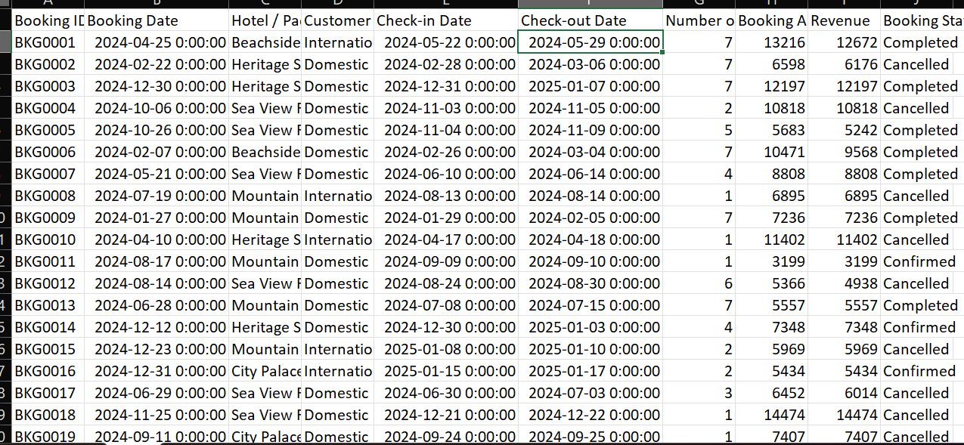
4.2 Key Result Findings
The analysis produced the following important business findings:
Total Realized Revenue: ₹13,114,757.00
Average Revenue Per Booking: ₹8,743.17
Customer Behavior: The average stay is 3.94 nights, showing a preference for short-to-medium stays.
TOURISM ANALYTICS
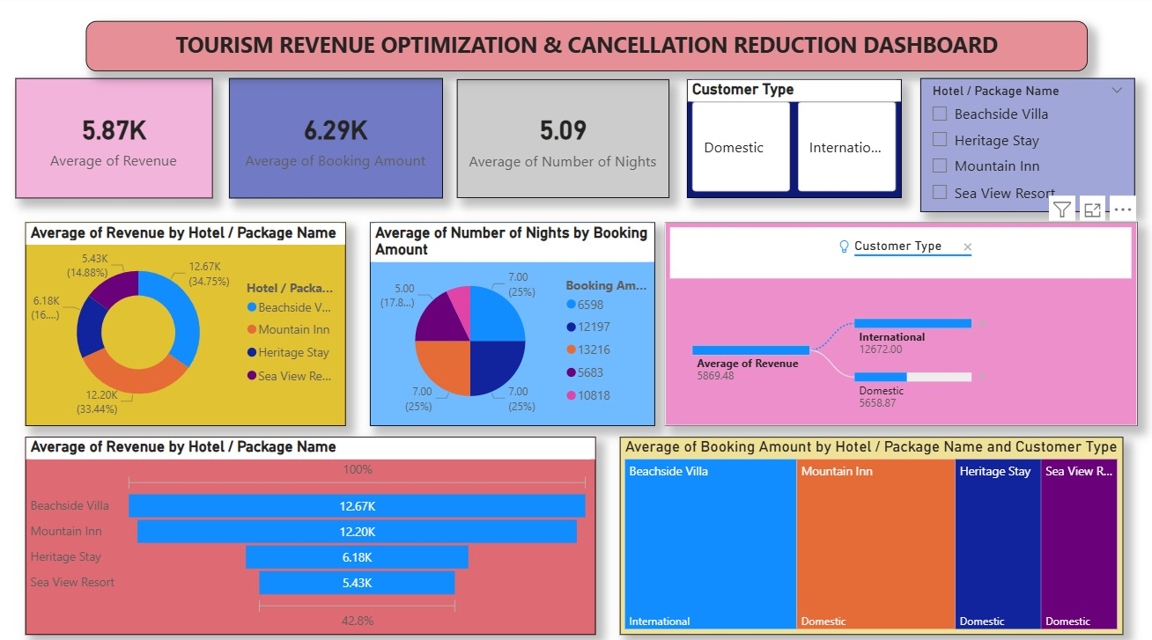
KPI DASHBOARD
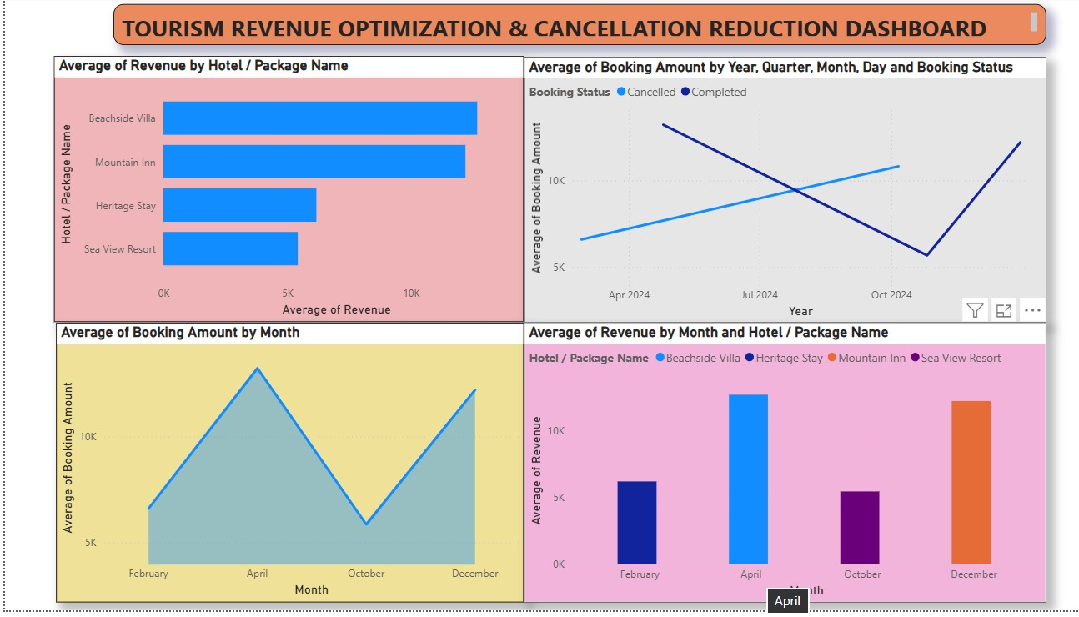

4.3 Visualization of Findings
Dashboard highlights include:
A Status Distribution Chart showing completed and cancelled bookings.
A Monthly Revenue Trend showing seasonal revenue fluctuations.

CHAPTER 5
DISCUSSION & CONCLUSION
5.1 Discussion of Results
The most important finding is the high cancellation level. This shows that the business can improve revenue by reviewing booking policies, strengthening retention strategies, and monitoring seasonal demand more closely.
Introduce flexible pricing and booking policies to reduce cancellations.
Use demand trends to improve occupancy planning and promotional offers.
5.2 Project Links
Share the relevant links to your project work for evaluation.
- GitHub Link of the Project: https://github.com/nazeemajid987-sketch/sk-nazeema-AI-Fellowship-project
- Video Recording of Project Demonstration:https://drive.google.com/file/d/16InB1mO5MSW9D01p7EYqyuckGuR9NJt-/view?usp=sharing
- Power BI / Dashboard Link (if applicable): https://drive.google.com/file/d/1NNk3zov38fNAqN3phFbU4NJ2TZiGa5lM/view?usp=sharing

5.3 Key Insights
The results provide a clear view of the current performance of the tourism business.
Revenue Concentration: A total revenue of ₹13,114,757.00 was generated from the completed bookings. This indicates strong earning potential from successful reservations.
Cancellation Risk: A large number of bookings were cancelled, showing a clear need for better booking retention and pricing strategies.
Stay Patterns: The average stay of 3.94 nights suggests that the business mainly serves short-term visitors, which is useful for planning and promotions.
5.4 Challenges and Limitations
Several limitations were identified during the project:
Static Data: The analysis is based on a fixed dataset. In a live business setting, booking data changes constantly and needs regular updates.
Lack of Qualitative Data: The dataset shows what happened, but not always why it happened. Customer feedback would improve the analysis.
Tool Constraints: AI tools work best when the data is clean and well structured, so careful preparation was necessary.
5.5 Conclusion and Summary
The project fulfills the AICW Fellowship requirement by showing how AI-supported analytics can improve business understanding in tourism.
Summary of Achievements:
Efficiency: Data cleaning and summary reporting were completed faster using Excel and Copilot.
Accuracy: Revenue and cancellation analysis were calculated clearly and consistently.
Strategy: The project produced practical recommendations for improving revenue and reducing cancellations.
Overall, the project demonstrates that even simple digital tools can help transform booking data into strategic business decisions.

REFERENCES

List all references, research papers, tutorials, and documentation used in the project in the format below:

[1] Microsoft Corporation. Microsoft Excel Documentation. Available at: https://support.microsoft.com/en-us/excel

[2] Microsoft Corporation. Power BI Documentation. Available at: https://learn.microsoft.com/en-us/power-bi/

[3] Microsoft Corporation. Microsoft Copilot — AI-Powered Productivity. Available at: https://copilot.microsoft.com

[4] Edunet Foundation. AICW Fellowship Program Guidelines. 2026.

APPENDICES

Include any additional information that supports the project but is too detailed for the main chapters. This may include:

Appendix A — Sample Data


Appendix B — Key Excel Formulas / DAX Measures Used
List any important formulas, functions, or DAX measures used in the project:
- =IFERROR(VLOOKUP(...), "Not Found") — used for data validatio
- =COUNTIF(range, criteria) — used to count duplicates
- Power BI DAX: Total Sales = SUM(Sales[Revenue]) — used in dashboard KPI card
- =IFERROR(VLOOKUP(...),"Not Found") - used for validation
=COUNTIF(range, criteria) - used to count duplicates
Power BI DAX: Total Revenue = SUM(Sales[Revenue]) - used for KPI cards
Appendix C — AI Prompts Used
List the key prompts you used with Copilot or AI Chatbot during the project:
- Prompt 1: "Summarize this sales data and identify the top 5 performing regions."
- Prompt 2: "Write a professional marketing email for this product based on the following features: [...]"
- Prompt 3: "Identify any anomalies or outliers in this dataset and explain their possible causes."
- Prompt 1: "Summarize this booking data and identify the main revenue trend."
Prompt 2: "Find the reasons behind high cancellation rates and suggest improvements."
Prompt 3: "Write a short business insight summary for this tourism dashboard."
Appendix D — Screenshot GallERY
